TASK 2 – **rectangle.rb**

This task was chosen from this repository: <https://github.com/dziugaspeciulevicius/Object-Oriented-Programming/tree/master/TASK1/src/com/company>

This task required to calculate rectangle perimeter, square size, diagonal length and rectangle diagonals intersection coordinates.

These are the methods to calculate the required aspects:

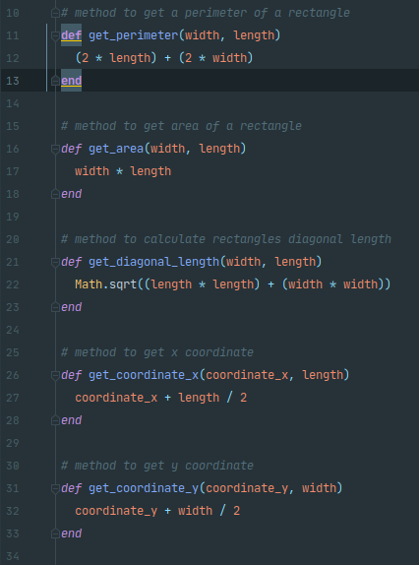

When running the program it requires to enter the length and the width of a rectangle and x,y coordinates. After entering these properties it will give us our calculation:

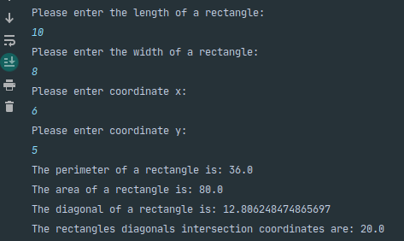

TASK2 – ***vigenere.rb***

This task was chosen from this repository: <https://github.com/dziugaspeciulevicius/Information-Security/blob/master/TASK1/src/com/company/Main.java>

To complete this task I had to install a library for it to work.

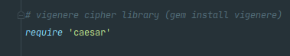

After that I wrote encryption and decryption methods. Had to find some help from fellow programmers on the internet, because it was quite hard to get it to work on ruby.

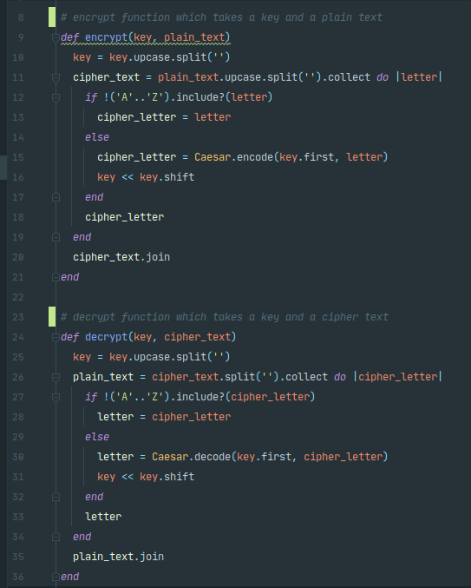

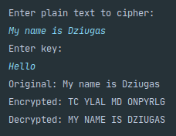 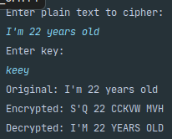

The cipher is not used to encrypt numbers so it just leaves it as it is.